INDOVISION SERVICES
TA-ATS Platform — Phase 1
LOW-LEVEL DESIGN (LLD)
Modules: AUTH (Auth & RBAC) · DASH (Dashboard) · JD (Job Description)

Version 1.0 | June 2026 | Based on Requirements v1.2 | Engineering & QA
API-First · Django 5 + DRF (shared API) · Next.js Web + Hybrid Mobile · PostgreSQL 16 · Celery/Redis · MCP

Table of Contents
1. Introduction
2. Project Code Structure
3. Database Schema (Tables & Indexes)
4. Entity Relationship Diagram
5. Module-by-Module Detailed Design
5.1 AUTH — Authentication & RBAC
5.2 DASH — Dashboard & Configuration
5.3 JD — Job Description Management
6. API Endpoint Catalog
7. MCP (Model Context Protocol)
8. Sequence Diagrams
9. Configuration Model
10. Background Jobs (Celery Tasks)
11. Error Handling & Logging
12. Settings & Environment Variables
13. Migration & Rollout Plan
14. DPDP (Digital Personal Data Protection)
15. RBAC Permission Matrix
16. Requirement Traceability Matrix
17. Test Strategy & Test Cases

1. Introduction

1.1 Purpose
This Low-Level Design translates TA-ATS Phase-1 requirements (v1.2) into an implementable design across three modules — Authentication & RBAC (AUTH), Dashboard & Configuration (DASH), and Job Description Management (JD). It defines code structure, PostgreSQL schema, ER model, services, state machines, pseudocode, API contracts, MCP-based AI, async jobs, configuration, error handling, rollout, DPDP compliance, RBAC matrix, traceability, and tests.

1.2 Scope (Phase 1)
- Modules: AUTH (REQ-AUTH-001…009), DASH (REQ-DASH-001…002), JD (REQ-JD-001…006, 008, 009, 010).
- Note: REQ-JD-007 is not defined in requirements v1.2 (row blank) — Clone JD is therefore excluded.
- Backend Python/Django REST Framework · Frontend Next.js · DB PostgreSQL · Async Celery/Redis · AI via MCP.
- API-first: every feature is delivered as a REST endpoint so the Next.js web app and the Phase-2 hybrid mobile app share one backend. Mobile client build is Phase-2, but its APIs are designed now.

1.3 Roles
Role | Scope | Key responsibilities
Super Admin | Full system | master setup, system params, audit logs
Admin | Organization | user mgmt, RBAC mgmt, config
Hiring Manager | Assigned jobs | approve JDs, assign recruiters, hiring decisions
Recruiter / PM | Owned jobs | author JDs, source, manage pipeline
Candidate | Self-service (opt) | apply, upload CV, view status

1.4 Architecture (API-First)
One Django REST Framework API is the single source of truth. BOTH the Next.js web app and the Phase-2 hybrid mobile app consume the same versioned REST endpoints with the same JWT auth and business-logic layer. Clients are thin; no business rule lives in a client.
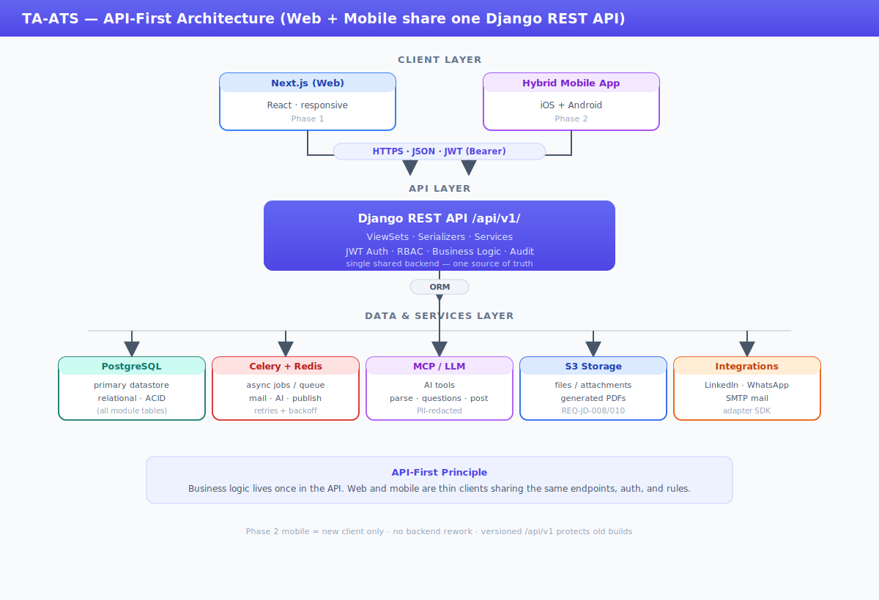

1.5 API Design Conventions (web + mobile shared)
- Versioned /api/v1/ — old mobile builds keep working when web moves to v2.
- Stateless JWT (access + refresh) — identical token flow on web and mobile.
- Uniform { response, message, result } envelope + stable error codes — clients parse one shape.
- Standard DRF pagination/filter; mobile requests smaller page sizes.
- Idempotency keys on create/publish POSTs — safe mobile retries on flaky networks.

2. Project Code Structure
Django monorepo (ats_core) + one app per module exposes the shared REST API. The Next.js web client is a sibling folder; the Phase-2 mobile app is a separate repo consuming the same /api/v1/ endpoints. Celery shares Django settings.
ta-ats/
├── ats_core/ settings/{base,dev,staging,prod}.py urls.py celery.py wsgi.py
├── apps/
│ ├── accounts/ # AUTH models serializers views permissions
│ │ # services middleware signals migrations tests
│ ├── dashboard/ # DASH
│ ├── jobs/ # JD + state_machine.py mcp.py pdf.py tasks.py
│ ├── candidates/ # SRC ranking/ outreach/ interviews/
│ ├── customer_portal/ ai_calling/ ai_flow/ ai_eval/ reports/ config/
│ ├── integrations/ # INT telephony/ jobboards/ messaging/ calendar/ nlp/
│ ├── api_gateway/ # versioning, throttling
│ └── MCP/ # Model Context Protocol
├── frontend/ # Next.js WEB client (consumes /api/v1)
│ # mobile/ (Phase-2 hybrid) = separate repo, same API
├── infra/ docker/ compose/ k8s/ scripts/ docs/ DPDP/
├── requirements/ base.txt dev.txt prod.txt └── manage.py
Layering: View → Service → Model. External calls behind apps/integrations; AI behind apps/MCP. Next.js calls the API via a typed client; never touches the DB.

3. Database Schema (Tables & Indexes)
PostgreSQL 16 · UTF-8 · schema per module. Audit columns (created_at, updated_at, created_by_id) on all tables.

3.1 AUTH tables
Table | Key columns | Index | REQ
auth_user | email(uniq), password_hash, is_active | email | 001
role | name, description | name | 006
user_role | user_id FK, role_id FK | (user,role) | 005/006
permission_matrix | role_id, module, action, allowed | (role,module,action) | 006
login_attempt | user_id, success, ip, ts | (user,ts) | 004
auth_event_log | user_id, event, ip, device, ts | (user,ts) | 008
password_history | user_id, password_hash, ts | user_id | 003
mfa_secret | user_id, totp_secret, enabled | user_id | 002

3.2 DASH tables
Table | Key columns | Index | REQ
dashboard_widget | role_id FK, widget_key, config JSON | role_id | 001
job_status_view | VIEW over jd.status | status | 002

3.3 JD tables
Table | Key columns | Index | REQ
jd | title, status, hiring_manager_id FK | status | 001
jd_question | jd_id FK, q_type, q_text, source | jd_id | 002
jd_version | jd_id FK, version_no, snapshot | jd_id | 003
jd_change_log | jd_id FK, event, actor_id, ip, ts | (jd,ts) | 004
jd_recruiter_assignment | jd_id FK, recruiter_id FK | (jd,recr) | 005
jd_job_post | jd_id FK, post_title, short_desc, image, logo | jd_id | 006/010
jd_social_post | jd_id FK, jd_job_post_id FK, channel, status | jd_id | 006
jd_attachment | jd_id FK, file_url, mime | jd_id | 008
jd_custom_param_def | param_key(uniq), data_type, active | param_key | 009
jd_custom_param_value | jd_id FK, param_id FK, value | (jd,param) | 009

3.4 jd — column detail
Column | Type | Key | Notes
jd_id | BIGINT | PK
title | VARCHAR(200) |  | 001
client_name | VARCHAR(200)
no_of_openings | INT |  | default 1
location | VARCHAR(200)
shift_type | VARCHAR(50)
budget_ctc | VARCHAR(100) |  | range
notice_period | VARCHAR(50)
must_have_skills | TEXT |  | sep field
good_to_have_skills | TEXT |  | sep field
qualification | VARCHAR(300)
description | LONGTEXT |  | manual/AI
status | VARCHAR(20) | IDX | state machine
input_method | VARCHAR(10) |  | manual|upload
hiring_manager_id | BIGINT | FK | → auth_user
created_by_id | BIGINT | FK | → auth_user

4. Entity Relationship Diagram
All three modules and how they connect. AUTH (red) provides identity consumed by JD (blue) and DASH (green) via foreign keys. JD-AI/post tables in purple.
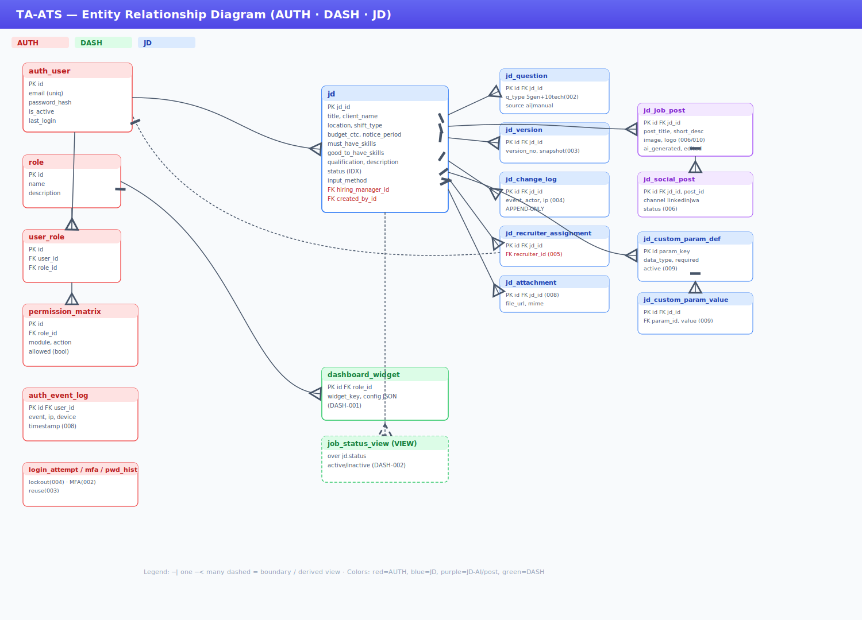
Reading the diagram: ─| = one, ─< = many. auth_user is referenced (not owned) by JD and DASH. jd is the hub for all JD child tables. dashboard_widget keys off role; job_status_view derives from jd.status.

5. Module-by-Module Detailed Design

5.1 AUTH — Authentication & RBAC
Login, MFA, lockout, JWT, RBAC matrix, password policy, audit. REQ-AUTH-001…009.

Services
Class | Responsibility
AuthService | authenticate(email,pwd); issue_tokens() JWT access+refresh (007)
LockoutService | record_attempt(); is_locked(); lock/unlock (004)
MFAService | enable(); verify_otp() email/TOTP (002)
PasswordService | validate_complexity(); check_reuse(last 5) (003); reset_via_email (009)
RBACService | has_permission(user,module,action) via permission_matrix (006)
AuditService | log(user,event,ip,device) append-only (008)
UserAdminService | create/edit/disable user, assign role (005)

Login State / Flow guards
- Account locked → 423 before credential check (004).
- Invalid creds → increment attempt; ≥5 → lock (004).
- MFA enabled → OTP required before token issue (002).

5.1.1 Pseudocode — login
What it does: validates credentials, blocks locked accounts, enforces MFA, then issues JWT and logs the event.
def login(email, pwd, ip, device):
user = find_user(email)
# STEP 1 - block if account already locked (AUTH-004)
if LockoutService.is_locked(user):
raise Locked('ACCOUNT_LOCKED')
# STEP 2 - verify password; on failure count the attempt
if not check_password(user, pwd):
LockoutService.record_attempt(user) # locks after 5 fails
AuditService.log(user,'login_failed',ip,device)
raise Unauthorized('INVALID_CREDENTIALS')
# STEP 3 - if MFA on, stop here and ask for OTP (AUTH-002)
if MFAService.enabled(user):
send_otp(user); return {'mfa_required': True}
# STEP 4 - success: issue JWT, reset counter, log (AUTH-007/008)
tokens = issue_tokens(user)
LockoutService.reset(user)
AuditService.log(user,'login_success',ip,device)
return {'access':tokens.access, 'refresh':tokens.refresh,
'role':user.role}

5.1.2 Pseudocode — RBAC check (used by every endpoint)
What it does: checks the role-permission matrix for the user's role; if no role allows the action, the request is denied (403).
def has_permission(user, module, action): # called by every API
# true if ANY of the user's roles allows this module+action
for role in user.roles:
if PermissionMatrix.allowed(role, module, action):
return True
return False # -> 403 FORBIDDEN (JD-006)

5.2 DASH — Dashboard & Configuration
Role-aware widgets (001) + active/inactive jobs (002).
Class | Responsibility
DashboardService | get_widgets(user.role) from dashboard_widget (001)
JobStatusService | active_jobs(), inactive_jobs() over jd.status (002)
WidgetConfigService | upsert_widget(role,key,config) — no code deploy

5.2.1 Pseudocode — load dashboard
What it does: loads only the widgets configured for the user's role, then fills each widget with its data.
def get_dashboard(user):
# widgets are configured per role - no code change (DASH-001)
widgets = get_widgets(user.role)
data = {}
for w in widgets: # fill each widget's data
if w.key == 'active_jobs':
data[w.key] = active_jobs(user) # DASH-002
elif w.key == 'pending_approvals':
data[w.key] = pending_for(user)
return {'widgets': widgets, 'data': data}

5.3 JD — Job Description Management
Full lifecycle per workflow V3.2 and REQ-JD-001…010 (007 excluded).
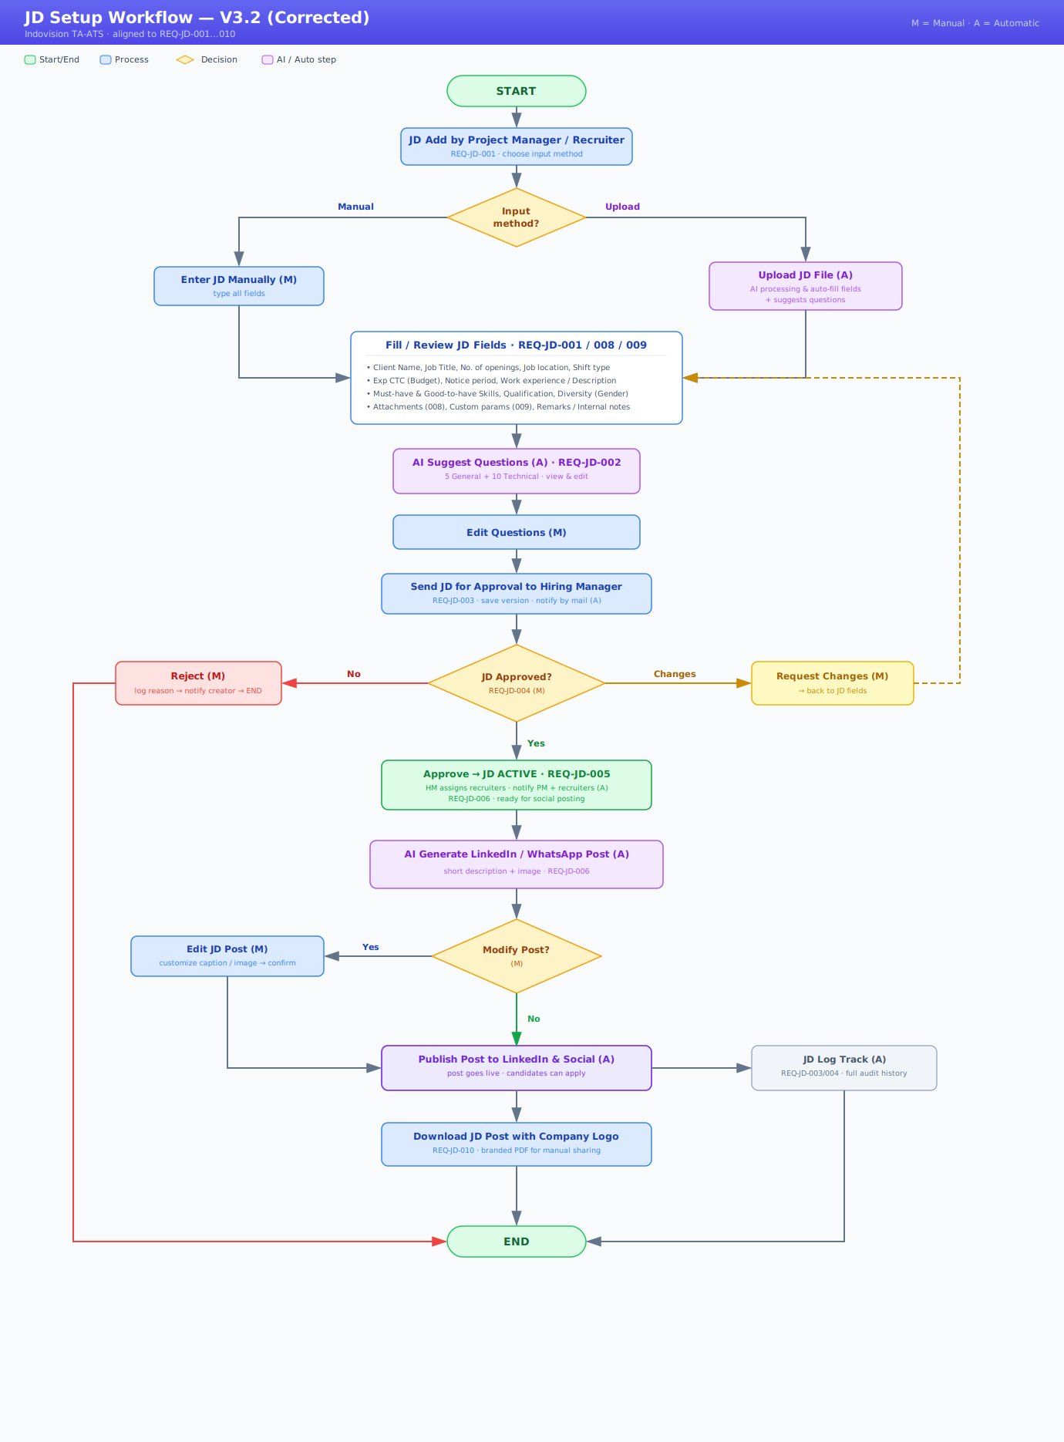

Services
Class | Responsibility
JDService | create_draft, update_fields, submit, change_status (state machine)
AIService (MCP) | parse_document (001), generate_questions 5+10 (002), generate_post (006)
ApprovalService | approve/reject/request_changes (004) + change-log + mail
AssignmentService | assign_recruiters (005) + notify
SocialPublisher | publish_linkedin / publish_whatsapp (006)
PdfService | build_jd_pdf — logo + watermark (010)
ChangeLogService | record(jd,event,actor,ip) single audit sink (004)
CustomParamService | list_active/upsert/soft_delete dynamic fields (009)

State Machine
From | Action | To | Actor
(none) | create | DRAFT | PM/Recruiter
DRAFT | submit | PENDING_APPROVAL | PM/Recruiter
PENDING_APPROVAL | approve | ACTIVE | HM
PENDING_APPROVAL | reject | REJECTED | HM
PENDING_APPROVAL | request_changes | DRAFT | HM
ACTIVE | close | CLOSED | PM/HM

5.3.1 Pseudocode — submit JD (003)
What it does: locks a completed DRAFT, saves an immutable version snapshot, moves it to PENDING, and emails the HM.
def submit_jd(jd_id, actor, ip):
jd = get_or_404(jd_id)
# only a DRAFT can be submitted
if jd.status != 'DRAFT': raise Conflict('JD_NOT_EDITABLE')
# must be complete + have questions before approval
validate_required_fields(jd)
if jd.questions.count()==0: raise ValidationError('Add questions')
with atomic():
# snapshot = version history (AUTH-JD-003)
JDVersion.create(jd, jd.versions.count()+1, serialize(jd))
jd.status='PENDING_APPROVAL'; jd.save()
ChangeLog.record(jd,'submitted',actor,ip)
send_mail_task.delay(jd.hiring_manager.email) # notify HM

5.3.2 Pseudocode — approve + assign (004/005)
What it does: HM approves a pending JD, assigns recruiters in the same step, marks it ACTIVE, then notifies everyone.
def approve_jd(jd_id, recruiter_ids, comment, actor, ip):
jd = get_or_404(jd_id)
assert jd.status == 'PENDING_APPROVAL'
# HM must pick at least one recruiter at approval (JD-005)
if not recruiter_ids: raise ValidationError('NO_RECRUITER')
with atomic():
jd.status='ACTIVE'; jd.save() # JD goes live
for rid in recruiter_ids: # assign team
JDRecruiterAssignment.create(jd, recruiter_id=rid)
ChangeLog.record(jd,'approved',actor,ip)
ChangeLog.record(jd,'assigned',actor,ip)
send_mail_task.delay(jd.created_by.email) # notify PM
for rid in recruiter_ids:
send_mail_task.delay(user(rid).email) # notify recruiters

5.3.3 Pseudocode — generate questions via MCP (002)
What it does: asks the AI (via MCP) for 5 general + 10 technical questions from the JD, then stores them as editable rows.
def generate_questions(jd_id):
jd = get_or_404(jd_id)
# call AI tool - send only job text, no personal data (DPDP)
res = MCP.call_tool('jd.generate_questions',
{'jd':jd_fields(jd), 'general':5, 'technical':10})
jd.questions.filter(source='ai').delete() # replace old AI set
save_questions(jd, res['general'], 'general')
save_questions(jd, res['technical'], 'technical')
# user can now edit/add/delete these (JD-002)

5.3.4 Pseudocode — generate, modify, publish post (006/010)
What it does: for an ACTIVE JD, AI drafts a social post (caption + image); HM may edit it; then it publishes to each channel.
def generate_post(jd_id):
jd = require_active(jd_id) # only ACTIVE JD can post
out = MCP.call_tool('jd.generate_post', {'jd':jd_fields(jd)})
# store editable draft (HM can modify before publishing)
return JDJobPost.create(jd, short_desc=out['caption'],
image_url=out['image'], company_logo=org.logo)
def publish_post(post_id, channels, actor, ip):
post = get_or_404(post_id)
for ch in channels: # e.g. linkedin, whatsapp
publish_social_task.delay(post.id, ch) # async send
JDSocialPost.create(post.jd, post, channel=ch)
ChangeLog.record(post.jd,'posted',actor,ip)

5.3.5 Pseudocode — custom params (009)
What it does: builds the JD form from fixed fields PLUS admin-defined extra fields, so new fields appear without code changes (JD-009).
def render_jd_form():
# fixed fields + any extra fields the admin configured
return static_jd_fields() + active_custom_fields()
def save_custom_values(jd, posted):
for p in active_custom_fields():
validate(p, posted.get(p.param_key)) # check type + required
JDCustomParamValue.upsert(jd, p, posted[p.param_key])

6. API Endpoint Catalog
Base /api/v1/. JWT required; RBAC per action (§15). Envelope { response, message, result }.

6.1 AUTH
Method | Endpoint | Role | Purpose / REQ
POST | /auth/login/ | Any | login → JWT · 001/002/004/007
POST | /auth/refresh/ | Any | refresh token · 007
POST | /auth/mfa/verify/ | Any | verify OTP · 002
POST | /auth/password/reset/ | Any | self reset · 009
POST | /admin/users/ | Admin | create/edit/disable · 005
GET/PUT | /admin/permissions/ | Admin | RBAC matrix · 006

6.2 DASH
Method | Endpoint | Role | Purpose / REQ
GET | /dashboard/ | All | role widgets · 001
GET | /dashboard/jobs/?status= | All | active/inactive · 002

6.3 JD
Method | Endpoint | Role | Purpose / REQ
POST | /jd/upload-parse/ | PM,Recr | AI parse · 001
POST | /jd/ | PM,Recr | create draft · 001
PUT | /jd/{id}/ | PM,Recr | update · 001/009
POST | /jd/{id}/generate-questions/ | PM,Recr | AI 5+10 · 002
PUT | /jd/{id}/questions/ | PM,Recr | modify Q · 002
POST | /jd/{id}/submit/ | PM,Recr | submit+version · 003
POST | /jd/{id}/approve/ | HM | approve+assign · 004/005
POST | /jd/{id}/reject/ | HM | reject · 004
POST | /jd/{id}/request-changes/ | HM | back to draft · 004
POST | /jd/{id}/generate-post/ | HM | AI post · 006
POST | /jd/{id}/posts/{pid}/publish/ | HM | publish · 006
GET | /jd/{id}/download-pdf/ | PM,HM,Recr | branded PDF · 010
POST | /jd/{id}/attachments/ | PM,Recr | upload · 008
GET | /jd/{id}/change-log/ | PM,HM,Admin | audit · 004
GET/POST | /admin/jd-params/ | Admin | custom params · 009

7. MCP (Model Context Protocol)
AI features via an MCP client (apps/MCP + jobs/mcp.py) — vendor-swappable, auditable, PII-redacted.
MCP Tool | Input → Output
jd.parse_document | file_text → JD fields (001)
jd.generate_questions | jd,5,10 → {general[],technical[]} (002)
jd.generate_post | jd,channel → {caption,image_prompt} (006)
class MCPService: # apps/MCP
def call_tool(self, name, payload):
redacted = dpdp_redact(payload) # strip PII (§14)
resp = self.client.invoke(name, redacted, timeout=30)
ChangeLog.record(None,'ai_call',system,{'tool':name,
'usage':resp.usage}) # audit
return resp.result
Rule: only job-spec text sent to the model — never candidate/personal data. Runs as Celery tasks (§10).

8. Sequence Diagrams

8.1 AUTH — login + MFA + JWT
User→API: POST /auth/login {email,pwd}
API→LockoutService: is_locked()? → 423 if locked
API→AuthService: check_password
invalid→record+log→ if>=5 lock →401
valid→ MFA? send OTP→verify
API→AuthService: issue JWT; RBAC load; Audit log
API→User: {access,refresh,role,perms}

8.2 JD — submit→approve→assign
PM→API: submit → validate, snapshot version, PENDING
API→Celery: mail HM
HM→API: approve {recruiter_ids} → ACTIVE, assign, log
API→Celery: mail PM + recruiters

8.3 JD — generate→modify→publish post
System→MCP: generate_post → caption+image
HM: Modify? yes→edit no→publish
HM→API: publish → Celery → linkedin+whatsapp
API→PdfService: branded PDF (010)

9. Configuration Model
Configurable item | Mechanism (no code deploy)
RBAC permissions | permission_matrix table — Admin UI (006)
Dashboard widgets | dashboard_widget per role (001)
JD custom parameters | jd_custom_param_def — Admin UI (009)
Lockout / JWT TTL / pwd policy | settings + DB config (003/004/007)
MFA on/off | per user / org policy (002)
Social channels | integrations adapters (linkedin/whatsapp)

10. Background Jobs (Celery Tasks)
Task | Trigger | Purpose
send_mail_task | auth + JD events | async email (008, JD notifications)
ai_parse_document_task | upload-parse | MCP parse (001)
ai_generate_questions_task | generate-questions | MCP 5+10 (002)
ai_generate_post_task | generate-post | MCP post (006)
publish_social_task | publish | LinkedIn/WhatsApp (006)
build_pdf_task | download-pdf | branded PDF (010)
purge_expired_task | nightly cron | DPDP retention (§14)
Reliability: retry+backoff; idempotency keys on publish/mail.

11. Error Handling & Logging
{ "response":"Failed","message":"<readable>",
"code":"JD_NOT_EDITABLE","result":null }
Code | HTTP | Meaning
VALIDATION_ERROR | 422 | field validation
INVALID_CREDENTIALS | 401 | login failed (001)
ACCOUNT_LOCKED | 423 | lockout (004)
FORBIDDEN | 403 | RBAC denied (006)
JD_NOT_EDITABLE | 409 | JD not DRAFT
NO_RECRUITER | 422 | approve w/o recruiter (005)
AI_UNAVAILABLE | 503 | MCP/LLM timeout
- Structured JSON logs (request id, user, route, latency).
- Audit → auth_event_log / jd_change_log (append-only, actor+IP).
- AI calls log tool + usage, never PII.

12. Settings & Environment Variables
# Backend (.env)
DJANGO_SETTINGS_MODULE=ats_core.settings.prod SECRET_KEY=...
DATABASE_URL=postgres://USER:PASS@HOST:5432/ta_ats
REDIS_URL= CELERY_BROKER_URL=
JWT_ACCESS_TTL=900 JWT_REFRESH_TTL=604800 # 007
LOCKOUT_MAX_ATTEMPTS=5 PWD_HISTORY=5 PWD_EXPIRY_DAYS=90 # 003/004
MFA_ENABLED=true # 002
MCP_SERVER_URL= MCP_API_KEY=
LINKEDIN_API_KEY= WHATSAPP_API_KEY= SMTP_...
S3_BUCKET= COMPANY_LOGO_URL= # 010
# Frontend (.env.local)
NEXT_PUBLIC_API_BASE=https://api.../api/v1

13. Migration & Rollout Plan
Phase | Activity | Notes
0 | Repos, CI/CD, envs | Django + Next.js pipelines
1 | Migrations AUTH+DASH+JD | seed roles + permission_matrix
2 | AUTH + login UI | JWT, MFA, lockout
3 | JD module + workflow | models→APIs→web wizard (same APIs ready for mobile)
4 | MCP AI | feature flag; mock in staging
5 | DASH dashboards | widgets per role
6 | UAT + DPDP review | sign-off, pen-test
7 | Production (blue-green) | rollback=prev image + migrate down
P2 | Mobile app (Phase 2) | new client only — reuses /api/v1, no backend rework

14. DPDP (Digital Personal Data Protection)
Principle | Implementation
Data minimisation | dpdp_redact() strips PII before MCP/LLM; only job text sent
Purpose limitation | personal data only for auth/assignment/notify
Consent / notice | candidate apply page: notice + consent before CV upload
Accuracy | JD version history (003)
Storage limitation | retention policy; purge_expired_task; CLOSED archived
Accountability | append-only audit (auth_event_log, jd_change_log) actor+IP (008/004)
Security | TLS, encryption at rest, RBAC, virus-scan uploads
Data-subject rights | export/erase via Admin; soft-close keeps audit
Key rule: no candidate/personal data sent to the LLM.

15. RBAC Permission Matrix
permission_matrix (Module × Action × Role). ✓ allowed. Editable by Admin/Super Admin (006).
Module · Action | Super | Admin | HM | Recr/PM | Cand
AUTH user mgmt | ✓ | ✓ | — | — | —
AUTH RBAC edit | ✓ | ✓ | — | — | —
DASH view | ✓ | ✓ | ✓ | ✓ | —
JD create/edit | ✓ | ✓ | — | ✓ | —
JD generate questions | ✓ | ✓ | — | ✓ | —
JD submit | ✓ | ✓ | — | ✓ | —
JD approve/reject | ✓ | — | ✓ | — | —
JD assign recruiters | ✓ | — | ✓ | — | —
JD post to social | ✓ | — | ✓ | — | —
JD download PDF | ✓ | ✓ | ✓ | ✓ | —
JD custom params | ✓ | ✓ | — | — | —
Apply / upload CV | — | — | — | — | ✓

16. Requirement Traceability Matrix
REQ ID | Design / Table | API / Service | Test Case
AUTH-001 | auth_user | /auth/login | TC-AU-01
AUTH-002 | mfa_secret | /auth/mfa/verify | TC-AU-02
AUTH-003 | password_history | PasswordService | TC-AU-03
AUTH-004 | login_attempt | LockoutService | TC-AU-04
AUTH-005 | admin/users | /admin/users | TC-AU-05
AUTH-006 | permission_matrix | RBACService | TC-AU-06
AUTH-007 | JWT | simplejwt | TC-AU-07
AUTH-008 | auth_event_log | AuditService | TC-AU-08
AUTH-009 | reset flow | /auth/password/reset | TC-AU-09
DASH-001 | dashboard_widget | /dashboard | TC-DA-01
DASH-002 | job_status_view | /dashboard/jobs | TC-DA-02
JD-001 | jd | upload-parse, POST /jd | TC-JD-01..03
JD-002 | jd_question | generate-questions | TC-JD-04,05
JD-003 | jd_version | submit | TC-JD-06,07
JD-004 | jd_change_log | approve/reject/changes | TC-JD-08..10
JD-005 | jd_recruiter_assignment | approve | TC-JD-11,12
JD-006 | jd_job_post+jd_social_post | generate/publish | TC-JD-13..15
JD-008 | jd_attachment | attachments | TC-JD-16
JD-009 | jd_custom_param_def/value | admin/jd-params | TC-JD-17,18
JD-010 | PdfService | download-pdf | TC-JD-19

17. Test Strategy & Test Cases

17.1 Strategy
- Backend: pytest-django + DRF APIClient — every endpoint, RBAC allowed/denied, and all state-machine transitions (mock MCP + mailer).
- Frontend: Jest + RTL for components; Playwright for E2E (login, JD wizard, approval).
- MCP mocked in CI; one nightly contract test against a sandbox MCP server.
- Coverage gate ≥85% — CI blocks merges below threshold.

17.2 Sample manual cases
ID | Steps | Expected | REQ
TC-AU-04 | 5 wrong passwords | locked (423) | AUTH-004
TC-AU-07 | valid login | JWT access+refresh | AUTH-007
TC-DA-01 | login as Recruiter | recruiter widgets shown | DASH-001
TC-JD-06 | submit DRAFT | PENDING, version=1, HM mailed | JD-003
TC-JD-08 | approve + 2 recruiters | ACTIVE, 2 assigned, mails | JD-004/005
TC-JD-13 | generate post (ACTIVE) | AI caption+image | JD-006
TC-JD-17 | admin add custom param | field appears on JD form | JD-009
TC-JD-19 | download PDF | logo+watermark | JD-010

17.3 Automation sample (pytest)
@pytest.mark.django_db
def test_lockout_after_5(client, user):
for _ in range(5): login(client,user.email,'wrong')
assert login(client,user.email,'wrong').status_code==423 # AUTH-004
@pytest.mark.django_db
def test_approve_requires_recruiter(hm, pending_jd):
c=APIClient(); c.force_authenticate(hm)
r=c.post(f'/api/v1/jd/{pending_jd.id}/approve/',
{'recruiter_ids':[]},format='json')
assert r.status_code==422 # JD-005
@pytest.mark.django_db
def test_dashboard_role_widgets(recruiter):
c=APIClient(); c.force_authenticate(recruiter)
r=c.get('/api/v1/dashboard/')
assert 'active_jobs' in r.json()['result']['data'] # DASH-001

17.4 Open items
# | Item | Owner
1 | REQ-JD-004: confirm changes-mail recipient = PM/Recruiter (recommended) | Product Owner
2 | Device Binding (in ToC, no REQ) — define or drop | Product Owner
3 | Max request-changes loops before escalation | Product Owner
— End of LLD —

INDOVISION SERVICES
TA-ATS Platform — Phase 1
LLD SUPPLEMENT
Class Diagram · Sequence Diagrams · Validation Rules · Error Handling · Annotated Pseudocode
+ Component, Deployment, Concurrency, Observability, Security additions
Field | Value
Document | LLD Supplement (companion to TA-ATS_LLD_Complete)
Version | 1.0
Date | 04 June 2026
Based on | Requirements v1.2 · LLD Complete (AKN)
Status | For Engineering & QA review
Scope | Fills/corrects sections 1-5 flagged + adds missing design artifacts

0. What This Supplement Adds & Corrects
This companion document addresses five areas requested for completion, plus additional design artifacts that a production LLD should contain. It is designed to slot into the master LLD; section cross-references use the master numbering where applicable.
# | Area | Status in base LLD | Action in this supplement
1 | Class Diagram | Absent | Added full UML class diagram (image + PlantUML code) — §1
2 | Sequence Diagram | Text shorthand only | Replaced with 3 proper UML sequence diagrams (image + code) — §2
3 | Validation Rules | Scattered inline | Consolidated field + business-rule validation tables — §3
4 | Error Handling | 7-row code table | Full taxonomy, exception→handler map, retry/timeout/circuit-breaker — §4
5 | Pseudocode + description | Partial, terse | All flows, each with intent/precondition/postcondition/errors — §5
+ | Extras | — | Component, deployment, concurrency, observability, NFR test hooks — §6-§10

1. Class Diagram
The service layer follows View → Service → Model. Services are stateless and injected with repositories; domain models are persistence entities. Dashed arrows denote usage/dependency; solid open arrows denote manage/read; the diamond denotes aggregation (User has many Roles).
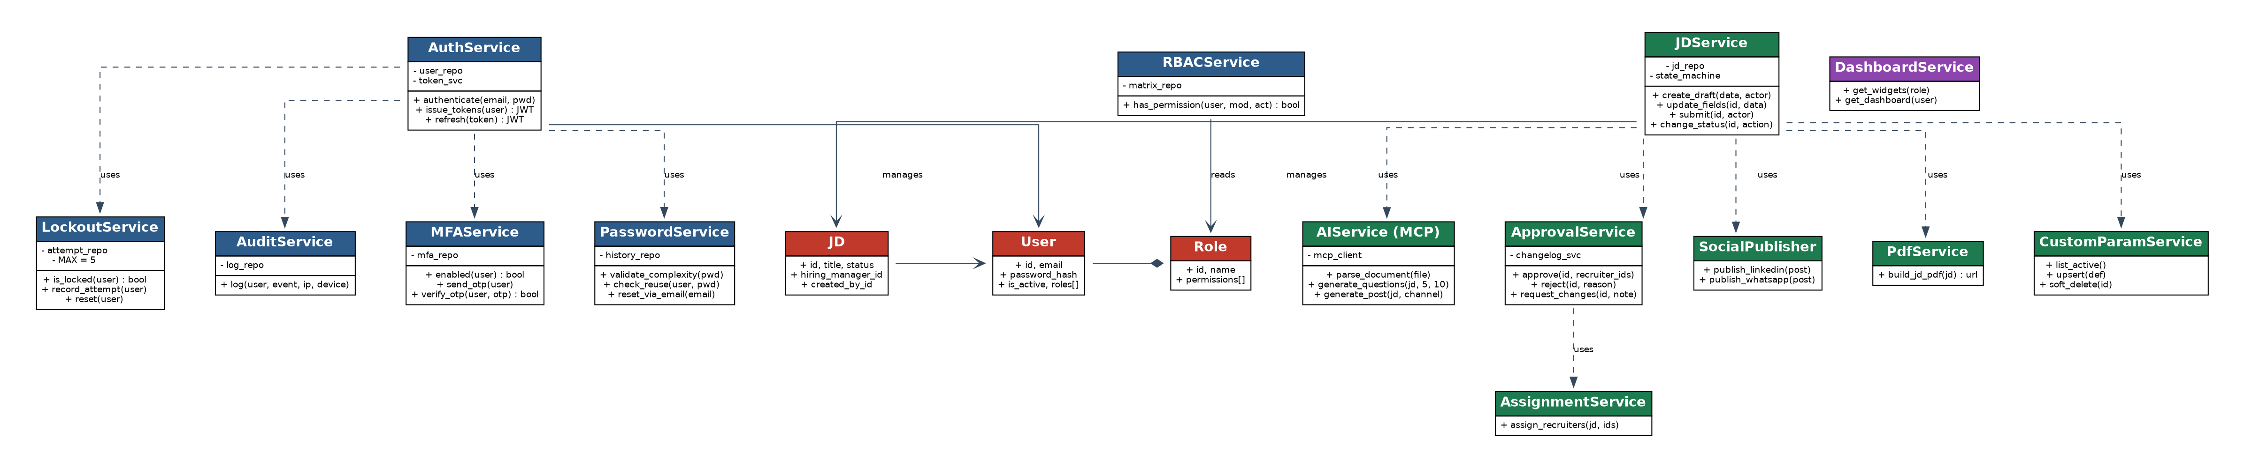
Figure 1.1 — TA-ATS service & domain class diagram (AUTH=blue, JD=green, DASH=purple, Models=red)

1.1 PlantUML source (editable)
PlantUML — render at plantuml.com or via IDE plugin
@startuml
skinparam classAttributeIconSize 0
package AUTH {
class AuthService {
- user_repo; - token_svc
+ authenticate(email,pwd)
+ issue_tokens(user): JWT
+ refresh(token): JWT
}
class MFAService { + enabled(u); + send_otp(u); + verify_otp(u,otp) }
class PasswordService { + validate_complexity(p); + check_reuse(u,p); + reset_via_email(e) }
class LockoutService { - MAX=5; + is_locked(u); + record_attempt(u); + reset(u) }
class RBACService { + has_permission(u,mod,act): bool }
class AuditService { + log(u,event,ip,device) }
}
package JD {
class JDService { + create_draft(); + update_fields(); + submit(); + change_status() }
class AIService { + parse_document(f); + generate_questions(jd,5,10); + generate_post(jd,ch) }
class ApprovalService { + approve(id,ids); + reject(id,reason); + request_changes(id,note) }
class AssignmentService { + assign_recruiters(jd,ids) }
class SocialPublisher { + publish_linkedin(p); + publish_whatsapp(p) }
class PdfService { + build_jd_pdf(jd): url }
class CustomParamService { + list_active(); + upsert(def); + soft_delete(id) }
}
package DASH { class DashboardService { + get_widgets(role); + get_dashboard(u) } }
class User { +id; +email; +password_hash; +is_active; +roles[] }
class JD { +id; +title; +status; +hiring_manager_id; +created_by_id }
class Role { +id; +name; +permissions[] }
AuthService ..> MFAService
AuthService ..> LockoutService
AuthService ..> PasswordService
AuthService ..> AuditService
AuthService --> User
RBACService --> Role
JDService ..> AIService
JDService ..> ApprovalService
ApprovalService ..> AssignmentService
JDService ..> SocialPublisher
JDService ..> PdfService
JDService ..> CustomParamService
JDService --> JD
User "*" o-- "*" Role
JD --> User : HM / creator
@enduml

2. Sequence Diagrams
Three core interactions are modelled as full UML sequence diagrams with lifelines, synchronous (solid) and return/async (dashed) messages, self-calls, guards in [brackets], and notes. Each is followed by editable PlantUML.

2.1 Login + MFA + JWT (REQ-AUTH-001/002/004/007/008)
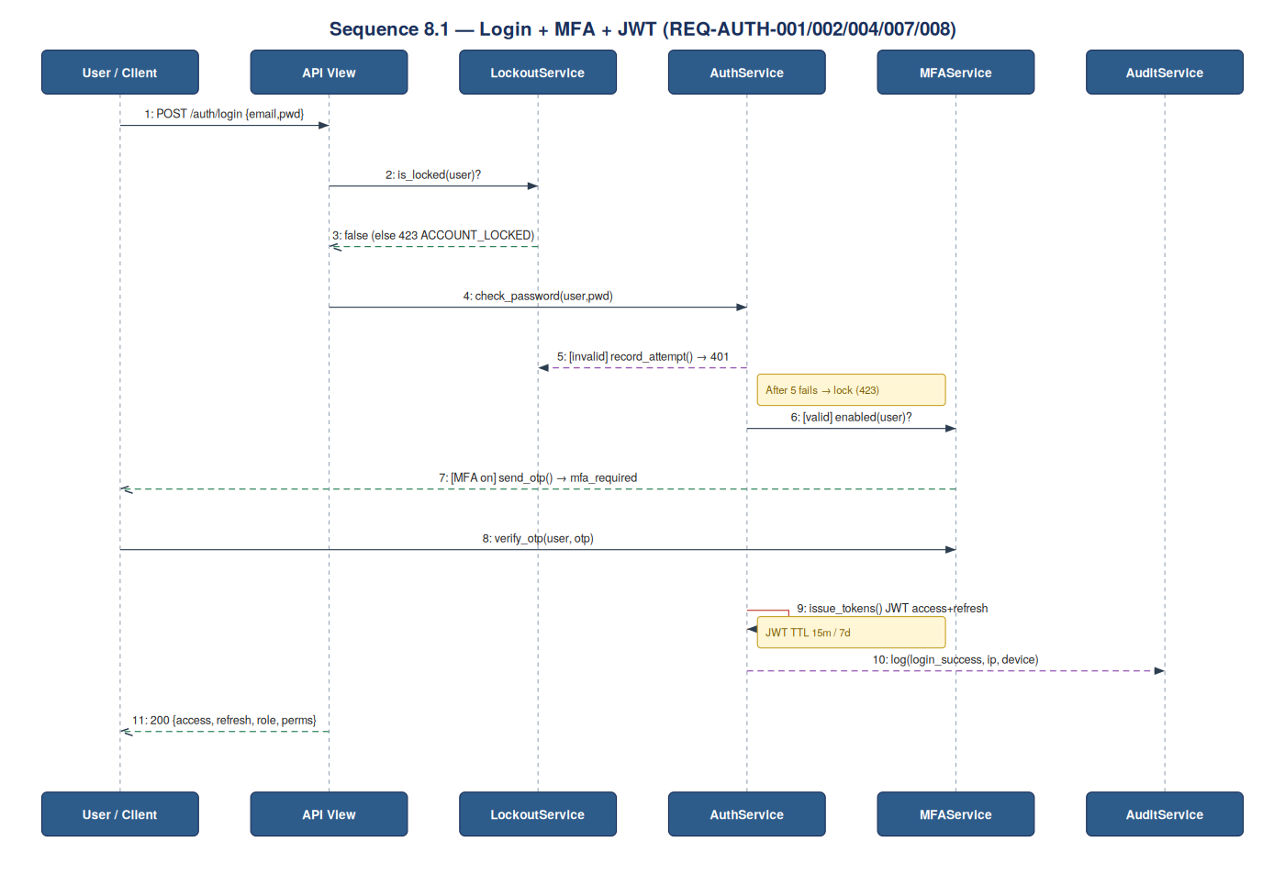
Figure 2.1 — Authentication with lockout guard, optional MFA, JWT issue, audit
PlantUML 2.1
@startuml
actor User
participant API
participant LockoutService as LCK
participant AuthService as AUTH
participant MFAService as MFA
participant AuditService as AUD
User -> API : POST /auth/login {email,pwd}
API -> LCK : is_locked(user)?
LCK --> API : false (else 423 ACCOUNT_LOCKED)
API -> AUTH : check_password(user,pwd)
alt invalid
AUTH -> LCK : record_attempt() // >=5 => lock
AUTH --> User : 401 INVALID_CREDENTIALS
else valid
AUTH -> MFA : enabled(user)?
opt MFA on
MFA --> User : send_otp() => mfa_required
User -> MFA : verify_otp(user,otp)
end
AUTH -> AUTH : issue_tokens() JWT(access15m,refresh7d)
AUTH -> AUD : log(login_success,ip,device)
API --> User : 200 {access,refresh,role,perms}
end
@enduml

2.2 JD Submit → Approve → Assign (REQ-JD-003/004/005)
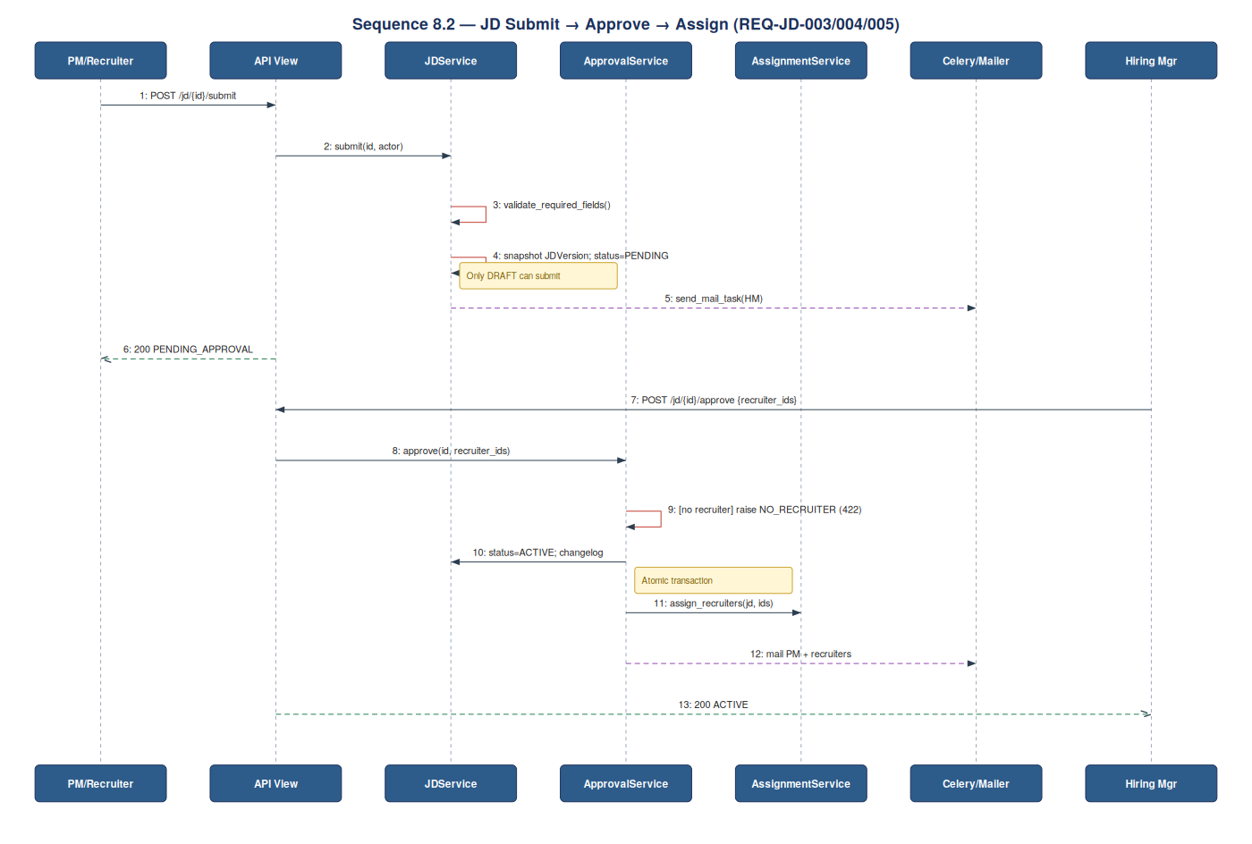
Figure 2.2 — Submit snapshots a version; approval is atomic and requires ≥1 recruiter
PlantUML 2.2
@startuml
actor PM
participant API
participant JDService as JD
participant ApprovalService as APV
participant AssignmentService as ASG
participant "Celery/Mailer" as CEL
actor "Hiring Mgr" as HM
PM -> API : POST /jd/{id}/submit
API -> JD : submit(id,actor)
JD -> JD : validate_required_fields() [only DRAFT]
JD -> JD : snapshot JDVersion; status=PENDING
JD -> CEL : send_mail_task(HM)
API --> PM : 200 PENDING_APPROVAL
HM -> API : POST /jd/{id}/approve {recruiter_ids}
API -> APV : approve(id,recruiter_ids)
APV -> APV : if empty -> raise NO_RECRUITER(422)
group atomic
APV -> JD : status=ACTIVE; changelog
APV -> ASG : assign_recruiters(jd,ids)
end
APV -> CEL : mail PM + recruiters
API --> HM : 200 ACTIVE
@enduml

2.3 Generate → Modify → Publish Post + PDF (REQ-JD-006/010)
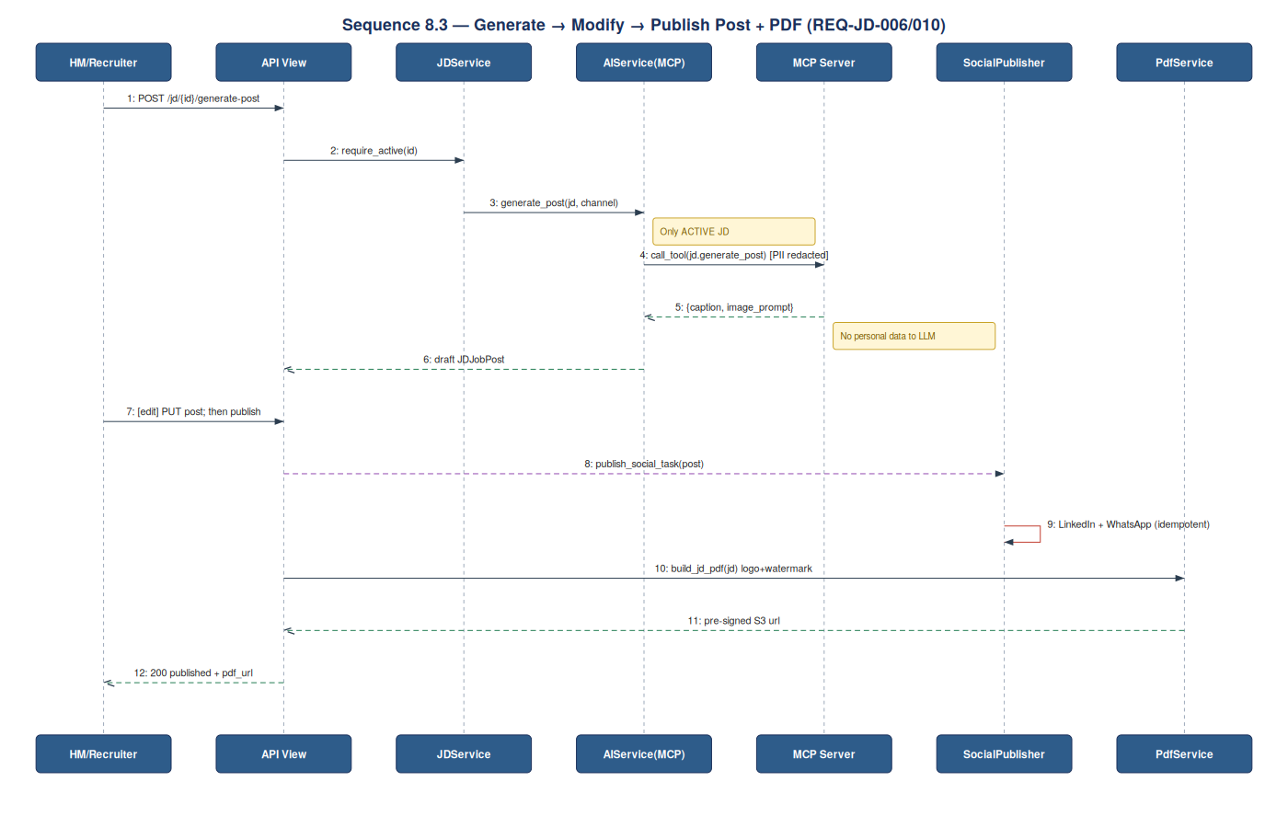
Figure 2.3 — AI draft via MCP (PII-redacted), optional edit, async publish, branded PDF
PlantUML 2.3
@startuml
actor HM
participant API
participant JDService as JD
participant "AIService(MCP)" as AI
participant "MCP Server" as MCP
participant SocialPublisher as SOC
participant PdfService as PDF
HM -> API : POST /jd/{id}/generate-post
API -> JD : require_active(id) [only ACTIVE]
JD -> AI : generate_post(jd,channel)
AI -> MCP : call_tool(jd.generate_post) [PII redacted]
MCP --> AI : {caption,image_prompt}
AI --> API : draft JDJobPost
HM -> API : [edit] PUT post; then publish
API -> SOC : publish_social_task(post) (async)
SOC -> SOC : LinkedIn + WhatsApp (idempotent)
API -> PDF : build_jd_pdf(jd) logo+watermark
PDF --> API : pre-signed S3 url
API --> HM : 200 published + pdf_url
@enduml

3. Validation Rules
Validation is layered: (a) serializer/field-level on input, (b) business-rule level in services, (c) state-machine guards. Field violations return 422 VALIDATION_ERROR with a field-keyed detail map; business-rule violations return their specific code.

3.1 AUTH field validation
Field | Rule | On failure
email | RFC 5322; required; unique on create | 422 field 'email'
password (set) | ≥12 chars; upper+lower+digit+symbol; not in last 5 | 422 'password' / PWD_REUSE
otp | 6 digits; numeric; TTL ≤ 5 min | 401 MFA_INVALID
role_ids | exist; assignable by actor's role | 422 'role_ids' / FORBIDDEN
login attempts | ≤5 within window else lock | 423 ACCOUNT_LOCKED

3.2 JD field validation
Field | Rule | On failure
title | required; 3–200 chars | 422 'title'
no_of_openings | integer ≥1; default 1 | 422 'no_of_openings'
budget_ctc | optional; numeric range 'min-max' | 422 'budget_ctc'
must_have_skills | ≥1 skill on submit | 422 'must_have_skills'
questions | ≥1 (5 general+10 technical AI set allowed) | 422 'questions'
attachment | PDF/DOCX only; ≤5 MB; virus-clean | 422 / FILE_REJECTED
recruiter_ids (approve) | ≥1; each is active Recruiter | 422 NO_RECRUITER
custom params | match data_type; required-if-active | 422 'param:<key>'

3.3 State-machine guards (business rules)
Transition | Guard | Violation code
submit (DRAFT→PENDING) | status==DRAFT AND fields valid AND ≥1 question | 409 JD_NOT_EDITABLE / 422
approve (PENDING→ACTIVE) | status==PENDING AND actor is HM AND ≥1 recruiter | 403 / 422 NO_RECRUITER
reject (PENDING→REJECTED) | status==PENDING AND actor is HM AND reason present | 409 / 422 'reason'
request_changes (PENDING→DRAFT) | status==PENDING AND actor is HM | 409 / 403
generate-post | status==ACTIVE | 409 JD_NOT_ACTIVE
close (ACTIVE→CLOSED) | status==ACTIVE AND actor is HM/PM | 409 / 403

Validation envelope example (422):
{
"response": "Failed",
"code": "VALIDATION_ERROR",
"message": "One or more fields are invalid.",
"errors": {
"title": ["This field is required."],
"must_have_skills": ["Add at least one skill before submitting."]
},
"result": null
}

4. Error Handling
All responses use the envelope { response, code, message, errors?, result }. Errors are raised as typed exceptions, caught by a single DRF exception handler, mapped to a code + HTTP status, logged (with request-id, user, route, latency), and audited when security-relevant.

4.1 Error code taxonomy
Code | HTTP | Category | Meaning / trigger | Retry?
VALIDATION_ERROR | 422 | Client | Field validation failed | No
INVALID_CREDENTIALS | 401 | Auth | Bad email/password (AUTH-001) | No
MFA_INVALID | 401 | Auth | Wrong/expired OTP (AUTH-002) | No
ACCOUNT_LOCKED | 423 | Auth | ≥5 failed attempts (AUTH-004) | After cooldown
TOKEN_EXPIRED | 401 | Auth | Access token expired → refresh | Use refresh
FORBIDDEN | 403 | Authz | RBAC denied (AUTH-006) | No
JD_NOT_EDITABLE | 409 | State | JD not in DRAFT | No
JD_NOT_ACTIVE | 409 | State | Post/PDF on non-ACTIVE JD | No
NO_RECRUITER | 422 | Business | Approve without recruiter (JD-005) | No
FILE_REJECTED | 422 | Upload | Wrong type/size/virus (JD-008) | No
DUPLICATE_EMAIL | 409 | Conflict | Email already exists | No
AI_UNAVAILABLE | 503 | Dependency | MCP/LLM timeout/error | Yes (backoff)
SOCIAL_PUBLISH_FAILED | 502 | Dependency | LinkedIn/WhatsApp error | Yes (idempotent)
RATE_LIMITED | 429 | Throttle | Too many requests | Yes (after delay)
INTERNAL_ERROR | 500 | Server | Unhandled exception | No

4.2 Exception → handler mapping
Centralised handling — every endpoint returns a consistent shape
# ats_core/exceptions.py
class AppError(Exception):
code='INTERNAL_ERROR'; http=500
class ValidationError(AppError): code='VALIDATION_ERROR'; http=422
class Unauthorized(AppError): code='INVALID_CREDENTIALS'; http=401
class Locked(AppError): code='ACCOUNT_LOCKED'; http=423
class Forbidden(AppError): code='FORBIDDEN'; http=403
class Conflict(AppError): code='JD_NOT_EDITABLE'; http=409
class DependencyError(AppError): code='AI_UNAVAILABLE'; http=503

# ats_core/handlers.py (DRF EXCEPTION_HANDLER)
def handle(exc, ctx):
err = exc if isinstance(exc, AppError) else AppError()
log.error(request_id, user, route, err.code, latency_ms)
if err.http in (401,403,423):
AuditService.log(user,'security_'+err.code, ip, device)
return JsonResponse(status=err.http, data={
'response':'Failed','code':err.code,'message':str(exc),
'errors':getattr(exc,'errors',None),'result':None })

4.3 Resilience for external dependencies
Concern | Policy
Retry | MCP & social: 3 attempts, exponential backoff (1s,2s,4s) + jitter
Timeout | MCP 30s; SMTP 30s; social 20s; DB statement 5s
Circuit breaker | Open after 5 consecutive MCP failures in 60s; half-open probe after 30s
Idempotency | publish_social & send_mail keyed by (entity_id, channel) to avoid dupes on retry
Fallback | AI_UNAVAILABLE → user may save draft & retry; never blocks JD creation
Dead-letter | Celery tasks exhausting retries pushed to DLQ + ops alert

5. Pseudocode (with description)
Each routine is documented with Intent, Preconditions, Postconditions, and Errors, followed by annotated pseudocode. This replaces the terse one-line descriptions in the base LLD and adds the flows that were missing (MFA verify, refresh, password reset, request-changes, attachment upload, PDF build).

5.1 login()
Aspect | Detail
Intent | Authenticate a user, enforce lockout & MFA, issue JWT, audit the event.
Preconditions | User exists or not (must not leak which); request has email, pwd, ip, device.
Postconditions | On success: access+refresh tokens returned, attempt counter reset, success audited.
Errors | ACCOUNT_LOCKED(423), INVALID_CREDENTIALS(401), MFA_INVALID(401).

def login(email, pwd, ip, device):
user = find_user(email) # constant-time even if None
if LockoutService.is_locked(user): # (AUTH-004)
raise Locked('ACCOUNT_LOCKED')
if not check_password(user, pwd): # bcrypt compare
LockoutService.record_attempt(user) # locks at 5
AuditService.log(user,'login_failed',ip,device)
raise Unauthorized('INVALID_CREDENTIALS')
if MFAService.enabled(user): # (AUTH-002)
send_otp(user); return {'mfa_required': True}
tokens = issue_tokens(user) # (AUTH-007)
LockoutService.reset(user)
AuditService.log(user,'login_success',ip,device) # (AUTH-008)
return {'access':tokens.access,'refresh':tokens.refresh,'role':user.role}

5.2 verify_mfa() (added)
Aspect | Detail
Intent | Validate the one-time code and complete login by issuing tokens.
Preconditions | A prior login() returned mfa_required; otp supplied within TTL.
Postconditions | Tokens issued; OTP invalidated; success audited.
Errors | MFA_INVALID(401) on wrong/expired code.

def verify_mfa(user, otp, ip, device):
if not MFAService.verify_otp(user, otp): # checks value + TTL<=5m
AuditService.log(user,'mfa_failed',ip,device)
raise Unauthorized('MFA_INVALID')
tokens = issue_tokens(user)
invalidate_otp(user)
AuditService.log(user,'mfa_success',ip,device)
return {'access':tokens.access,'refresh':tokens.refresh}

5.3 refresh_token() (added)
Aspect | Detail
Intent | Exchange a valid refresh token for a new access token (with rotation).
Preconditions | Refresh token present, unexpired, not revoked.
Postconditions | New access (and rotated refresh) returned; old refresh revoked.
Errors | TOKEN_EXPIRED(401), FORBIDDEN(403) if revoked/reused.

def refresh_token(refresh):
claims = decode(refresh)
if revoked(refresh) or expired(claims):
raise Unauthorized('TOKEN_EXPIRED')
revoke(refresh) # rotation: one-time use
new = issue_tokens(user_of(claims))
return {'access':new.access,'refresh':new.refresh}

5.4 reset_password() (added)
Aspect | Detail
Intent | Self-service reset via emailed, signed, single-use token.
Preconditions | Email may or may not exist (response identical to avoid enumeration).
Postconditions | If valid token+new pwd: password updated, history appended, sessions revoked.
Errors | VALIDATION_ERROR(422) on weak/reused password; silent on unknown email.

def request_reset(email):
user = find_user(email)
if user: send_signed_reset_link(user, ttl=30m)
return ok() # always 200 (no enumeration)

def perform_reset(token, new_pwd):
user = verify_signed_token(token) # else 422
PasswordService.validate_complexity(new_pwd)
if PasswordService.check_reuse(user,new_pwd): raise ValidationError('PWD_REUSE')
set_password(user,new_pwd); append_history(user)
revoke_all_sessions(user)
AuditService.log(user,'pwd_reset', ip='-', device='-')

5.5 has_permission() (RBAC)
Aspect | Detail
Intent | Authorize an action; called by every protected endpoint.
Preconditions | Authenticated user with ≥1 role; module+action supplied.
Postconditions | Boolean; deny path returns 403 to caller.
Errors | FORBIDDEN(403) when no role grants the action.

def has_permission(user, module, action):
for role in user.roles:
if PermissionMatrix.allowed(role, module, action):
return True
return False # caller -> 403 FORBIDDEN (AUTH-006)

5.6 submit_jd()
Aspect | Detail
Intent | Lock a complete DRAFT, snapshot a version, move to PENDING, email HM.
Preconditions | JD in DRAFT; required fields valid; ≥1 question.
Postconditions | Immutable JDVersion stored; status=PENDING; HM notified async.
Errors | JD_NOT_EDITABLE(409), VALIDATION_ERROR(422).

def submit_jd(jd_id, actor, ip):
jd = get_or_404(jd_id)
if jd.status != 'DRAFT': raise Conflict('JD_NOT_EDITABLE')
validate_required_fields(jd) # (§3.2)
if jd.questions.count()==0: raise ValidationError('Add questions')
with atomic():
JDVersion.create(jd, jd.versions.count()+1, serialize(jd)) # (JD-003)
jd.status='PENDING_APPROVAL'; jd.save()
ChangeLog.record(jd,'submitted',actor,ip)
send_mail_task.delay(jd.hiring_manager.email)

5.7 approve_jd() + assign
Aspect | Detail
Intent | HM approves a pending JD, assigns recruiters atomically, notifies all.
Preconditions | JD in PENDING; actor is HM; ≥1 valid recruiter id.
Postconditions | status=ACTIVE; assignments persisted; PM+recruiters mailed.
Errors | NO_RECRUITER(422), FORBIDDEN(403), JD_NOT_EDITABLE(409).

def approve_jd(jd_id, recruiter_ids, comment, actor, ip):
jd = get_or_404(jd_id)
assert jd.status=='PENDING_APPROVAL' # else 409
if not recruiter_ids: raise ValidationError('NO_RECRUITER') # (JD-005)
with atomic():
jd.status='ACTIVE'; jd.save()
for rid in recruiter_ids:
JDRecruiterAssignment.create(jd, recruiter_id=rid)
ChangeLog.record(jd,'approved',actor,ip)
ChangeLog.record(jd,'assigned',actor,ip)
send_mail_task.delay(jd.created_by.email)
for rid in recruiter_ids: send_mail_task.delay(user(rid).email)

5.8 request_changes() (added)
Aspect | Detail
Intent | HM sends a PENDING JD back to DRAFT with a note; loops the workflow.
Preconditions | JD in PENDING; actor is HM; note present.
Postconditions | status=DRAFT; change logged; PM/creator emailed with note.
Errors | JD_NOT_EDITABLE(409), FORBIDDEN(403), VALIDATION_ERROR(422).

def request_changes(jd_id, note, actor, ip):
jd = get_or_404(jd_id)
if jd.status!='PENDING_APPROVAL': raise Conflict('JD_NOT_EDITABLE')
if not note: raise ValidationError('note')
with atomic():
jd.status='DRAFT'; jd.save()
ChangeLog.record(jd,'changes_requested',actor,ip,meta={'note':note})
send_mail_task.delay(jd.created_by.email, note) # (JD-004)

5.9 upload_attachment() (added)
Aspect | Detail
Intent | Attach a supporting document to a JD after a safety pipeline.
Preconditions | JD exists & editable by actor; file is PDF/DOCX ≤5MB.
Postconditions | Virus-clean file stored on S3; row in jd_attachment; change logged.
Errors | FILE_REJECTED(422), JD_NOT_EDITABLE(409).

def upload_attachment(jd_id, file, actor, ip):
jd = get_or_404(jd_id)
require_editable(jd) # DRAFT or per-policy
if file.mime not in ('application/pdf','...wordprocessingml'):
raise ValidationError('FILE_REJECTED')
if file.size > 5*MB: raise ValidationError('FILE_REJECTED')
if not virus_scan_clean(file): raise ValidationError('FILE_REJECTED')
key = s3_put(file, prefix=f'jd/{jd_id}/')
JDAttachment.create(jd, file_url=key, mime=file.mime) # (JD-008)
ChangeLog.record(jd,'attachment_added',actor,ip)

5.10 generate_questions() (MCP)
Aspect | Detail
Intent | Ask the model for 5 general + 10 technical questions; store editable rows.
Preconditions | JD has enough field content; MCP reachable.
Postconditions | Old AI set replaced; new questions persisted (source='ai').
Errors | AI_UNAVAILABLE(503) on MCP timeout.

def generate_questions(jd_id):
jd = get_or_404(jd_id)
res = MCP.call_tool('jd.generate_questions',
{'jd':jd_fields(jd),'general':5,'technical':10}) # PII-redacted
jd.questions.filter(source='ai').delete()
save_questions(jd, res['general'],'general')
save_questions(jd, res['technical'],'technical') # (JD-002)

5.11 generate_post() + publish_post()
Aspect | Detail
Intent | Draft a social post via MCP, allow edit, then publish async to channels.
Preconditions | JD ACTIVE; channels valid; tokens present in Secrets Manager.
Postconditions | Draft stored; on publish, async tasks per channel; audit recorded.
Errors | JD_NOT_ACTIVE(409), AI_UNAVAILABLE(503), SOCIAL_PUBLISH_FAILED(502).

def generate_post(jd_id):
jd = require_active(jd_id) # else 409
out = MCP.call_tool('jd.generate_post', {'jd':jd_fields(jd)})
return JDJobPost.create(jd, short_desc=out['caption'],
image_url=out['image'], company_logo=org.logo)

def publish_post(post_id, channels, actor, ip):
post = get_or_404(post_id)
for ch in channels:
publish_social_task.delay(post.id, ch, idem_key=(post.id,ch))
JDSocialPost.create(post.jd, post, channel=ch)
ChangeLog.record(post.jd,'posted',actor,ip) # (JD-006)

5.12 build_jd_pdf() (added)
Aspect | Detail
Intent | Render a branded PDF (logo + watermark) and return a pre-signed URL.
Preconditions | JD exists; company logo configured.
Postconditions | PDF stored on S3; short-lived signed URL returned.
Errors | INTERNAL_ERROR(500) on render failure (retried once).

def build_jd_pdf(jd_id):
jd = get_or_404(jd_id)
html = render_template('jd_pdf.html', jd=jd, logo=org.logo)
pdf = html_to_pdf(html, watermark=org.name)
key = s3_put(pdf, prefix=f'jd/{jd_id}/pdf/')
return s3_presigned_url(key, ttl=600) # (JD-010)

5.13 get_dashboard()
Aspect | Detail
Intent | Return only the widgets configured for the user's role, filled with data.
Preconditions | Authenticated user with a role.
Postconditions | Widget list + per-widget data payload.
Errors | FORBIDDEN(403) if role has no DASH access.

def get_dashboard(user):
widgets = get_widgets(user.role) # (DASH-001) no code change
data = {}
for w in widgets:
if w.key=='active_jobs': data[w.key]=active_jobs(user) # (DASH-002)
elif w.key=='pending_approvals': data[w.key]=pending_for(user)
return {'widgets':widgets,'data':data}

5.14 render_jd_form() + save_custom_values()
Aspect | Detail
Intent | Compose JD form from static + admin-defined fields; validate & persist values.
Preconditions | Active custom-param definitions present.
Postconditions | Form reflects dynamic fields; values validated by data_type and persisted.
Errors | VALIDATION_ERROR(422) per offending param key.

def render_jd_form():
return static_jd_fields() + active_custom_fields() # (JD-009)

def save_custom_values(jd, posted):
for p in active_custom_fields():
validate(p, posted.get(p.param_key)) # type + required-if-active
JDCustomParamValue.upsert(jd, p, posted[p.param_key])

6. Component Diagram (added)
Logical components and their dependencies. The API Gateway fronts stateless services; AI is isolated behind the MCP boundary; async work runs on Celery workers; persistence is split across PostgreSQL (OLTP), TimescaleDB (audit), and S3 (blobs).
Component sketch (PlantUML-style)
[Next.js Web] --HTTPS--> [API Gateway]
[API Gateway] --> [Auth Service] --> (PostgreSQL)
[API Gateway] --> [JD Service] --> (PostgreSQL)
[API Gateway] --> [Dashboard Svc]--> (PostgreSQL view)
[JD Service] --> [AIService] --MCP--> [[MCP Server/LLM]]
[JD Service] --> [Celery] --> [Notification Svc] --> {{SendGrid/WhatsApp}}
[JD Service] --> [Celery] --> [SocialPublisher] --> {{LinkedIn/WhatsApp}}
[JD Service] --> [PdfService] --> (S3)
All services --> [AuditService] --> (TimescaleDB)
[Celery] <--> (Redis broker)

7. Deployment View (added)
Node | Runs | Notes
CloudFront + S3 | Next.js static assets | CDN, TLS termination at edge
ECS/K8s svc: api | Django+DRF (gunicorn) | HPA on CPU/RPS; stateless
ECS/K8s svc: worker | Celery workers | Scales on queue depth; DLQ
ElastiCache | Redis | Broker + cache + lock
RDS | PostgreSQL 16 (Multi-AZ) | OLTP; PITR backups
RDS/self-managed | TimescaleDB | Append-only audit
S3 | Uploads, post images, PDFs | SSE-AES256; lifecycle to Glacier
Secrets Manager | API keys, DB creds | Rotation enabled

8. Concurrency & Transactions (added)
- Approval is wrapped in a single DB transaction (status + assignments + change-log) — partial failure rolls back.
- JD edit uses optimistic locking via a version column; concurrent save of a stale version returns 409 and the client refetches.
- publish_social and send_mail are idempotent on (entity_id, channel) so Celery retries never double-post or double-email.
- Submitting a JD locks it out of edit (status guard) preventing race between author edit and HM approval.

9. Observability (added)
Signal | What | Where
Logs | Structured JSON: request_id, user, route, code, latency_ms | CloudWatch
Metrics | p50/p95 latency, error rate by code, queue depth, MCP timeouts | DataDog/CloudWatch
Traces | API → service → MCP/DB spans with request_id | APM
Audit | Security & JD events (actor+IP), immutable | TimescaleDB
Alerts | 5xx burst, circuit-breaker open, DLQ>0, uptime<99.5% | On-call

10. NFR Test Hooks (added)
NFR | Target | How verified
API p95 | <400ms | k6/Locust load test in staging
AI auto-fill | <8s (5MB) | Contract test w/ sample files
Email delivery | <30s | Synthetic probe + Celery metric
Availability | ≥99.5%/mo | Uptime monitor + error budget
Concurrency | 200 users | Soak test, no degradation
Audit write | <500ms, none dropped | Insert latency metric + count reconcile

