INDOVISION SERVICES
PRODUCT REQUIREMENTS DOCUMENT (PRD) V-1

Focus: Product Goals
Scope: User Login → Dashboard | TA-ATS Phase 1 | June 2026

1. Objective
Need to develop a login module for ATS application so that its users can access its modules securely and secure ATS content from publicly access.

2. Workflow diagram
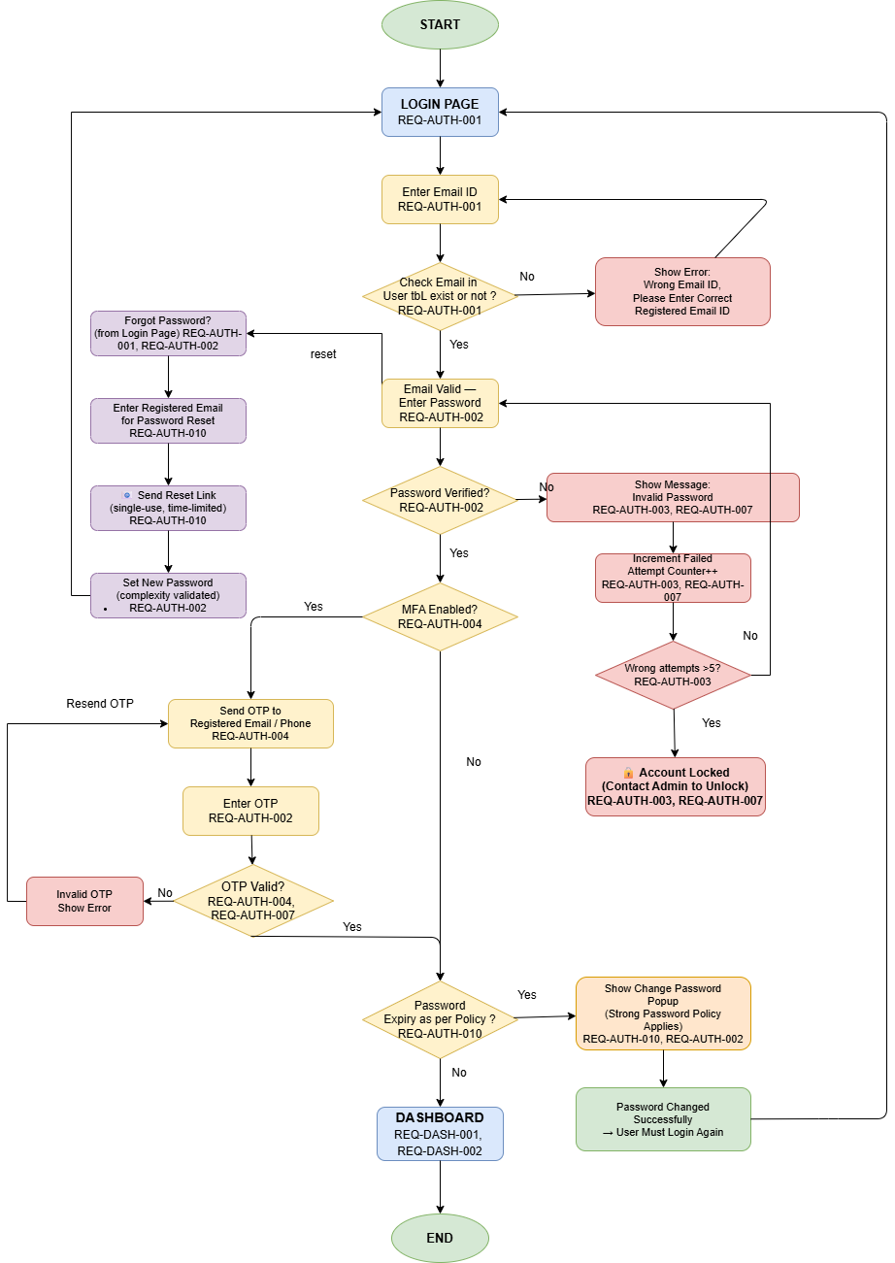

3. Functional requirements

3.1 Authentication (Auth)
Req-Auth | Points
Req-Auth-001 | Email is the login identifier.
Req-Auth-002 | Passwords are stored as argon2 hashes — never in plain text.
Req-Auth-003 | 5 consecutive failed login attempts → account should be locked.
Req-Auth-004 | On successful login with MFA authentication, fail count resets to 0 and last login is updated.
Req-Auth-005 | JWT access token TTL = 15 minutes; refresh token TTL = 7 days (both configurable).
Req-Auth-006 | Expired access token → 401; clients use refresh token to get a new access token.
Req-Auth-007 | Every login attempt (success or failure) is logged with user, IP, and timestamp.
Req-Auth-008 | After login, the dashboard shows boxes with count like Active/Inactive Jobs, pending for approval jobs. And keep login logs
Req-Auth-009 | Users can log out from logout link.
Req-Auth-010 | Users can reset passwords with their registered email id if they forget or expired after 90 days

3. 2 Dashboard (Dash)
Req-Dash | Points
Req-Dash-001 | Will show boxes job summary counts

4. Non-functional requirements
- CSRF protection
- XSS protection
- SQL Injection protection
- Security audit logging

5. UI reference
- Login page: centered card with email input, password input, 'Sign in' button. Error shown below button.
- Dashboard page: top nav bar with username + logout. Grid of widget cards. Each widget shows a title + count or list.
- Locked state: login page shows 'Account locked. Contact administrator.'

6. Tech Stack
Layer | Choice
Backend | Python 3.12, Django 5 framework and FastAPI
Auth | Django rest framework-simple jwt (JWT access + refresh)
Database | PostgreSQL 16 (relational, JSONB for widget config)
Async | Celery + Redis (audit log writes, future email)
Frontend | Next.js (React) — SPA, responsive
Infra | Docker (Phase 1); Kubernetes (Phase 2)
GitHub | Code version control
Postman | API testing

